

SRI LANKA INSTITUTE OF INFORMATION TECHNOLOGY

[Enterprise Standards and Best Practices for IT Infrastructure](http://courseweb.sliit.lk/course/view.php?id=137)

**4th Year 2nd Semester 2016**

Name: **K.G.Bandulasena**

SLIIT ID: **IT13510954**

Group Number: -

Practical Session: **WE Tuesday**

Practical Number: **VMotion_Requirements**

Date of Submission: **17th September 2016**

Date of Evaluation : _____________________

Evaluators Signature : _____________________

**What is VMotion ?**

VMware VMotion enables the live migration of running virtual machines from one physical server to another with zero downtime, continuous service availability, and complete transaction integrity. It is transparent to users.

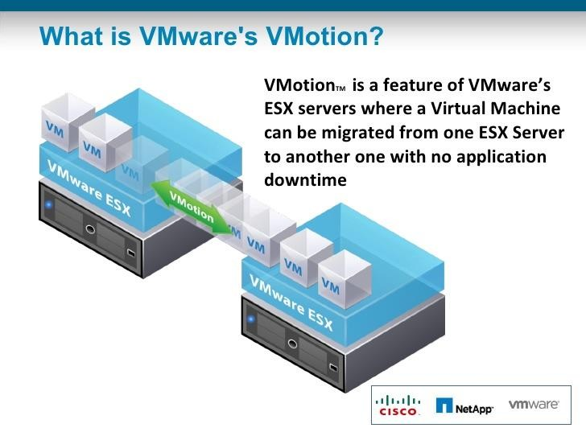

**VMotion lets you:**

Automatically optimize and allocate entire pools of resources for maximum hardware utilization and availability.

Perform hardware maintenance without any scheduled downtime.

Proactively migrate virtual machines away from failing or underperforming servers.

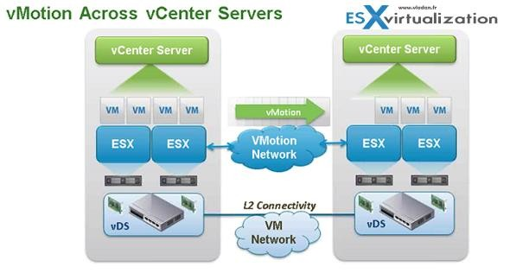

**How VMotion Work?**

There are three basic technologies that allow VMotion to dynamically align resources according to business priorities.

First, the entire state of a virtual machine is encapsulated by a set of files stored on shared storage. VMware’s clustered Virtual Machine FileSystem (VMFS) allows multiple installations of ESX Server to access the same virtual machine files concurrently.

Second, the active memory and precise execution state of the virtual machine is rapidly transferred over a high speed network. This allows the virtual machine to instantaneously switch from running on the source ESX Server to the destination ESX Server. VMotion keeps the transfer period imperceptible to users by keeping track of on-going memory transactions in a bitmap. Once the entire memory and system state has been copied over to the target ESX Server, VMotion suspends the source virtual machine, copies the bitmap to the target ESX Server, and resume s the virtual machine on the target ESX Server. This entire process takes less than two seconds on a Gigabit Ethernet network.

Third, the networks used by the virtual machine are also virtualized by the underlying ESX Server. This ensures that even after the migration, the virtual machine network identity and network connections are preserved. VMotion manages the virtual MAC address as part of the process. Once the destination machine is activated, VMotion pings the network router to ensure that it is aware of the new physical location of the virtual MAC address. Since the migration of a virtual machine with VMotion preserves the precise execution state, the network identity, and the active network connections, the result is zero downtime and no disruption to users.

**Requirements:**

Having a Virtual Center.

2 have physical servers with ESXi installed.

Having a Gigabit network cable to connect from one server to another directly.

Actions taken on the physical server.

Connect a network cable to "Direct Attach" which means to connect directly from one server to the other server

Actions to be taken through vSphere Client connected to VirtualCenter. We connect to Virtual Center and gain access to one of the servers 2.

1. select the tab **Configuration-> Networking**

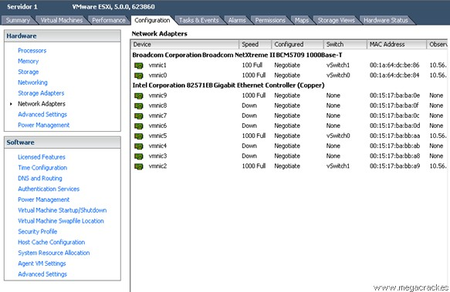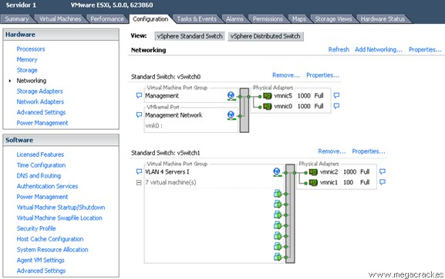

3. Select **VMKernel** and click on **Next.**

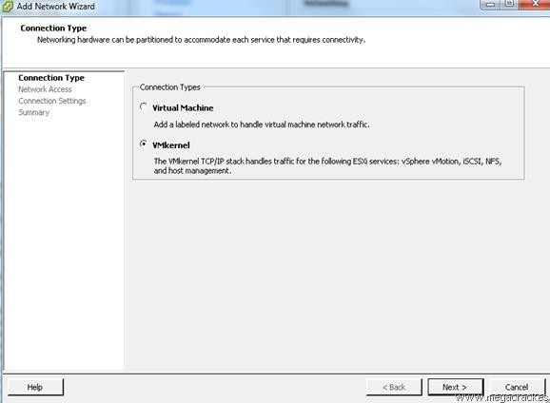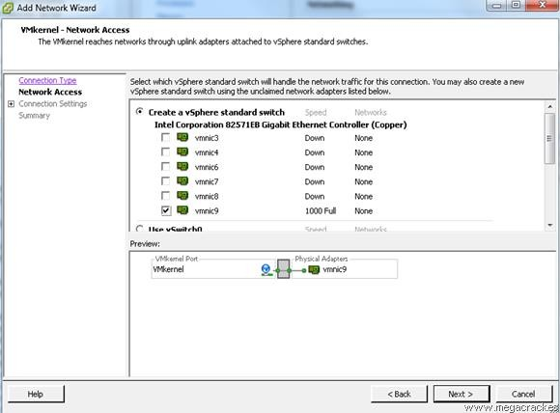

4. We set **Use this port group for vMotion.**

We wrote a **Label Network** different if you want (optional) and click on **Next.** We for

example we put **Vmotion.**

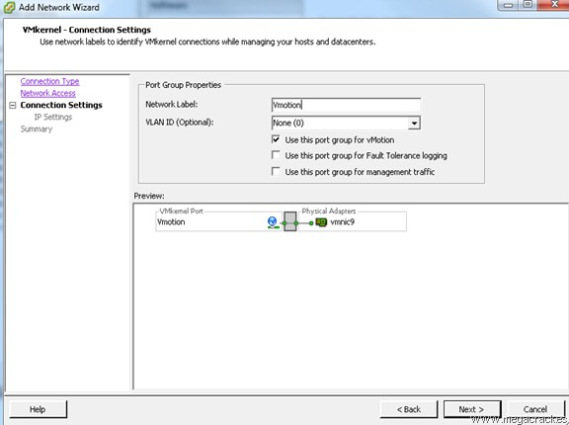

**IP Address: 50.50.50.1**

**Subnet Mask: 255.255.255.252** (Since we will use only 2 ip's).

Click on **Next.**

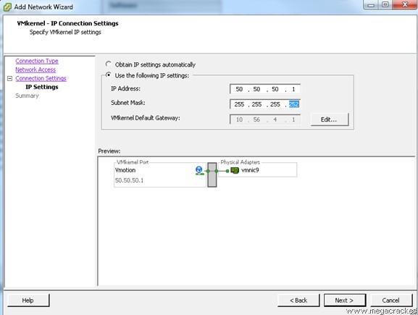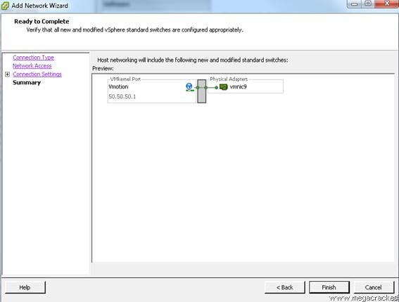

7. We select the tab **Configuration-> Network Adapters** and we see that we have visibility of the new connections.

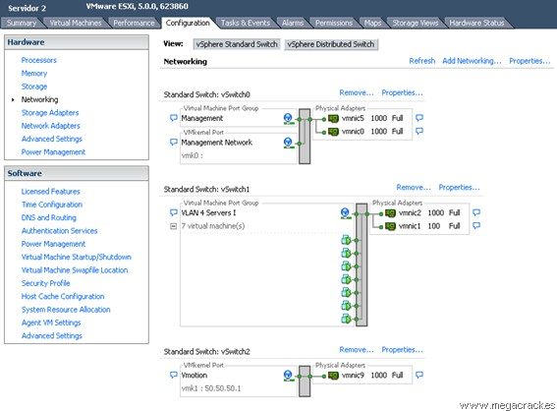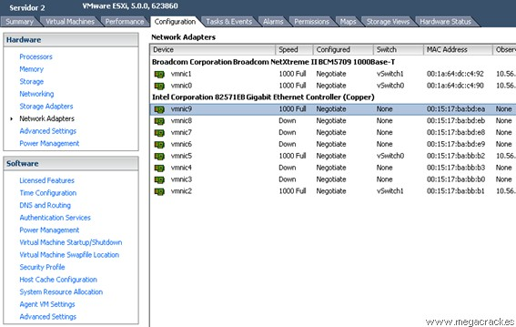

9. Click on **Add Networking** to create the vSwitch.

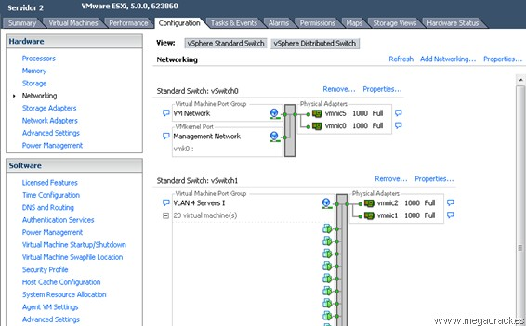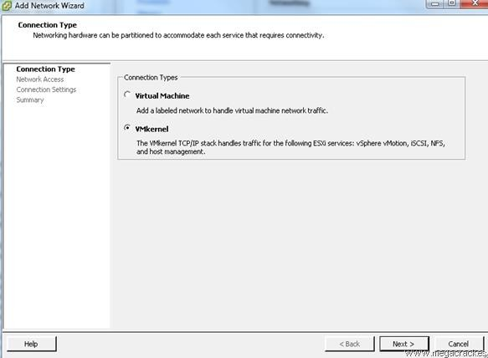

11. **Use this port group for VMotion.**

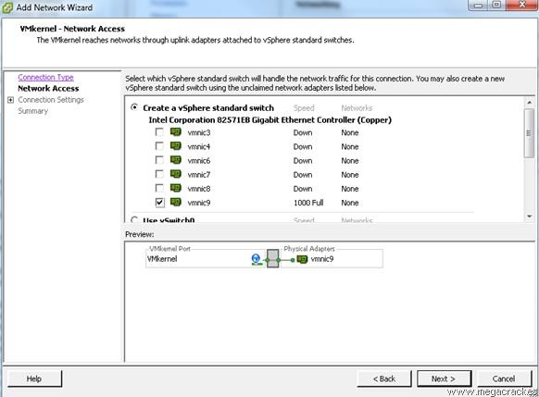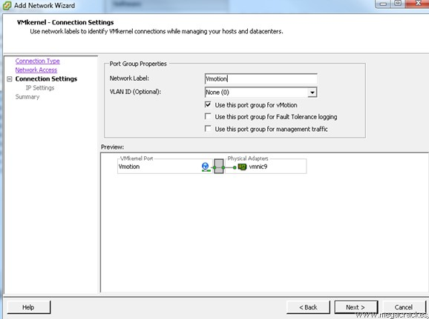

12. **IP Address: 50.50.50.2** (This ip must be different from the server that configured earlier

1).

**Subnet Mask: 255.255.255.252**

Click on **Next.**

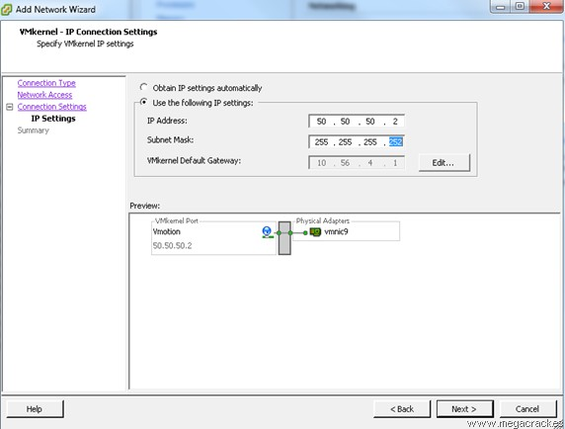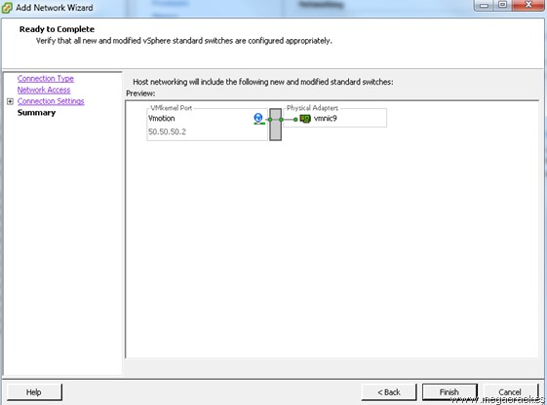

Now what we will do to ensure that the entire system is working properly migrate a VM from one ESXi to the other using Vmotion functionality you just configured.

14. Click on **Migrate.**

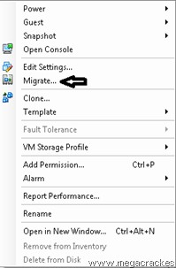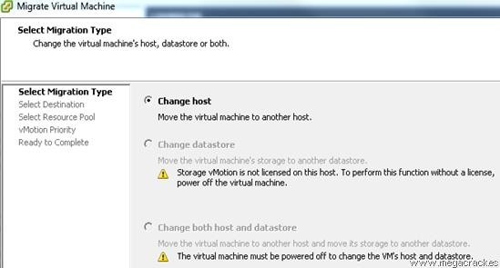

16. Select the target server where to move the virtual machine.

Click on **Next**.

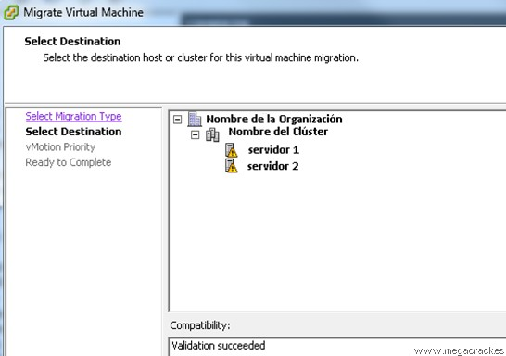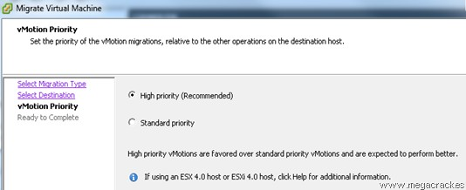

18. Click on **Finish** to start the migration.

